1. Overview of Annotations
- @Entity
  - Usage: This annotation is used to mark a class as a JPA entity. It indicates that the class is mapped to a database table.
  - Explanation: When you annotate a class with @Entity, it tells Spring Data JPA that this class should be persisted in the database.
- @Id
  - Usage: This annotation marks the primary key of the entity.
  - Explanation: It tells JPA that the field is the unique identifier for the entity.
Code Example:
- @Table
  - Usage: Used to specify the name of the table in the database.
  - Explanation: It maps the entity to a specific table in the database, allowing for custom table names.
- @Column(columnDefinition)
  - Usage: This allows you to define the column with custom SQL syntax.
  - Explanation: It is used when you need a specific column type or default value.

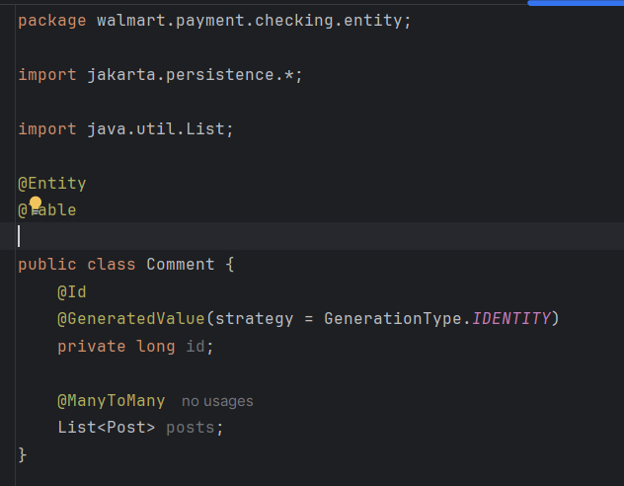

- @RestController
  - Usage: This annotation is used to define a Spring MVC controller where every method is automatically annotated with @ResponseBody, meaning that the response will be written directly to the HTTP response body.
  - Explanation: This is used in web services and APIs.
- @GetMapping, @PostMapping, @PutMapping, @DeleteMapping
  - Usage: These are shortcuts for defining HTTP methods for controllers.
  - Explanation: They are part of Spring MVC to map specific HTTP methods (GET, POST, PUT, DELETE) to Java methods.
- @Autowired
  - Usage: This annotation is used to automatically inject beans into Spring components (like @Service, @Controller, etc.).
  - Explanation: @Autowired tells Spring to automatically wire a bean into the field or constructor. This helps reduce manual bean configuration and allows Spring to manage the dependencies.
- @Transactional
  - Usage: This annotation is used to define transaction boundaries in Spring. It ensures that all operations within a method are executed within a single transaction.
  - Explanation: When you annotate a method with @Transactional, Spring will handle the transaction for you. If the method completes successfully, the transaction is committed; if an exception occurs, it is rolled back.
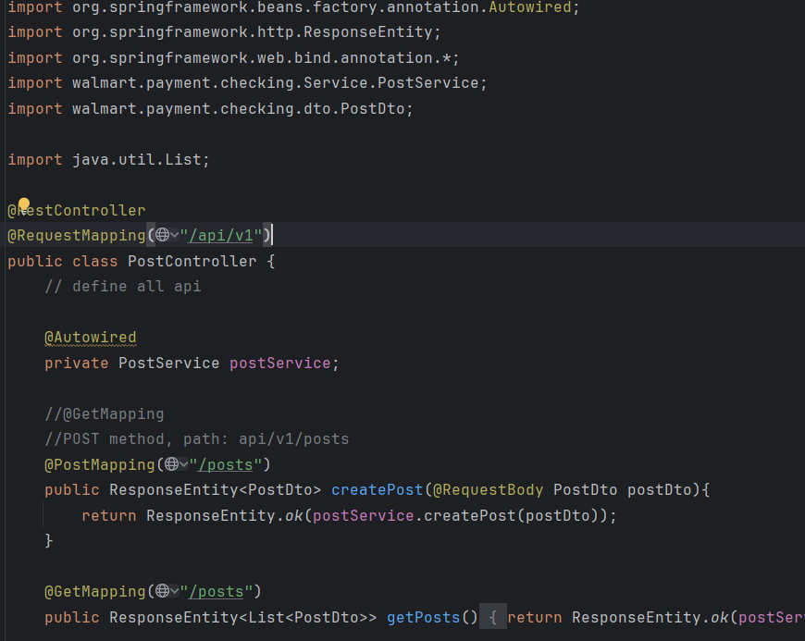
2. How do the annotations specify the table in the database?
- columnDefinition: This attribute allows you to provide a custom SQL definition for the column. It allows you to define the column type, size, default value, etc., at the database level. In this case:
- The column will be created as a VARCHAR with a maximum length of 255 characters.
- The default value for this column will be 'John Snow' (so when a new row is inserted without specifying a value for name, it will default to 'John Snow').
- name: Specifies the name of the column in the database. In this case, the column will be named STUDENT_NAME (instead of studentName).
- length: Specifies the length of the column. The length of 50 means that the STUDENT_NAME column will be able to store up to 50 characters.
- nullable: Specifies whether the column allows null values. Here, nullable = false means the STUDENT_NAME column will not allow null values (a value must always be provided when inserting or updating a record).
- unique: Specifies whether the column should have a unique constraint. Here, unique = false means that the STUDENT_NAME column does not need to be unique, i.e., multiple rows can have the same studentName.
3. What is the default column names of the table in database for @Column ?
The @Column annotation is used to define how the fields firstName and operatingSystem should be mapped to columns in the database. Since no additional attributes are specified in the @Column annotations, the default behavior is applied.
Default Behavior
When the @Column annotation is used without any additional attributes, the default behavior is as follows:
- Default Column Names:
  - The column names in the database will be derived from the field names of the Java class. By default, JPA uses the exact field names as the column names.
  - firstName will be mapped to a column named first_name.
  - operatingSystem will be mapped to a column named operating_system.
- Column Type:
  - By default, for fields of type String, JPA will create a column with the VARCHAR type in the database. The length of the column is typically set to 255 characters unless configured otherwise.
- Nullable:
  - The nullable attribute of the @Column annotation defaults to true. This means that the columns first_name and operating_system will allow null values unless specified otherwise.
- Length:
  - For String fields, the default length is typically 255 characters, unless a different length is specified in the annotation.
- Unique:
  - The unique attribute of the @Column annotation defaults to false, meaning there will be no unique constraint on the columns by default.

4. What are the layers in springboot application? what is the role of each layer?
- 1. Controller Layer (Web Layer)
Role:
  - Handles HTTP Requests and Responses: The Controller layer is responsible for receiving incoming HTTP requests, processing them, and returning HTTP responses.
  - Acts as an Interface: It is the interface between the client (frontend or external systems) and the backend logic of the application.
Responsibilities:
  - Receives HTTP requests (e.g., via @GetMapping, @PostMapping, @PutMapping, @DeleteMapping annotations).
  - Processes the request and communicates with the service layer for further action (such as data manipulation or validation).
  - Sends appropriate HTTP responses (usually JSON or XML) back to the client.
  - Performs basic validation and error handling
- 2. Service Layer (Business Logic Layer)
Role:
  - Contains Business Logic: The Service layer encapsulates the core business logic of the application. It is used to process data from the controller and interact with the repository layer.
Responsibilities:
  - Defines business rules and operations.
  - Coordinates data retrieval and manipulation from the repository layer.
  - Communicates between the controller and the repository layers, ensuring that the business logic is applied before data is stored or retrieved from the database.
- Repository Layer (Persistence Layer)
Role:
  - Interacts with the Database: The Repository layer is responsible for accessing the database to retrieve, store, update, and delete entities.
  - Data Persistence: This layer abstracts away the details of the database and allows you to work with Java objects instead of writing SQL queries manually.
Responsibilities:
  - Perform CRUD (Create, Read, Update, Delete) operations on database entities.
  - Manage database transactions and connections.
  - Interact with the database through JPA (Java Persistence API), Spring Data JPA, or other ORM frameworks (e.g., MyBatis).
- Entity Layer (Domain Model)
Role:
  - Represents Database Tables: Entities are Java classes that represent the structure of a table in the database.
  - Maps to Database Tables: Each entity class is mapped to a database table, and each field corresponds to a column in that table.
Responsibilities:
  - Contain the fields that represent data.
  - Are annotated with @Entity to indicate that the class is a JPA entity.
  - Can have relationships with other entities, represented by annotations such as @OneToMany, @ManyToOne, @ManyToMany, @OneToOne`.
- DTO Layer (Data Transfer Object)
Role:
  - Data Transfer: The DTO layer is used to transfer data between different layers of the application (e.g., between the controller and the service).
  - Reduces Data Overexposure: DTOs can help limit the amount of data exposed to the client, ensuring that only necessary fields are returned, without exposing internal entity structures.
Responsibilities:
  - Acts as a wrapper around the data that needs to be transferred.
  - Reduces the coupling between the domain model (entities) and the layers interacting with external systems (like the controller).
  - Can be used to aggregate multiple entities or omit sensitive information.
- Exception Handling Layer (Optional)
Role:
  - Centralizes Error Handling: This layer is responsible for handling errors, exceptions, and unexpected behavior in the application.
  - Provides Standardized Error Responses: It ensures that all errors are caught and transformed into a consistent format for clients.
Responsibilities:
  - Define global exception handling using annotations like @ControllerAdvice.
  - Return meaningful error messages and HTTP status codes.
  - Log errors for debugging and traceability.
- Security Layer (Optional)
Role:
  - Handles Authentication and Authorization: This layer deals with securing the application, ensuring that users are authenticated and authorized to access specific resources.
  - Manages Sessions and Tokens: Often includes managing JWT tokens, OAuth2, or session-based security for protecting endpoints.
Responsibilities:
  - Configure Spring Security for user authentication and authorization.
  - Define roles, permissions, and security policies for accessing endpoints.
5. Step 1: Postman Request
- Postman sends an HTTP GET request to the endpoint
Step 2: Controller Layer
- The Controller layer receives the request. The controller is responsible for handling incoming HTTP requests, processing the request (if necessary), and returning a response.
- In this case, the UserController will handle the request. Spring's @RestController annotation maps the incoming request to a method.
- The controller method getUserById(id) is invoked. The id parameter is extracted from the URL using @PathVariable. The controller delegates the actual business logic to the Service layer.
Step 3: Service Layer
- The Service layer processes the business logic. In this case, the UserService handles the request to fetch the user.
- The service layer interacts with the Repository layer to retrieve the necessary data from the database.
- The Service receives the id, uses the UserRepository to fetch the data from the database, and then converts the User entity into a UserDTO (Data Transfer Object) to return.
Step 4: Repository Layer
- The Repository layer interacts with the database. The UserRepository extends JpaRepository or CrudRepository, providing CRUD operations without the need to write custom SQL queries.
- The Repository uses JPA to fetch the User entity from the database. The findById method of JpaRepository is used to get the user by id.
Step 5: Entity Layer
- The User entity represents a table in the database. The User object is mapped to a database record.
- After fetching the User object from the database, it is passed back to the Service layer.
Step 6: DTO Layer
- The UserDTO (Data Transfer Object) is used to transfer data between layers. It is a simplified version of the User entity that may contain only the fields needed by the client.
- The Service layer converts the User entity into a UserDTO before returning it to the Controller.
Step 7: Response Back to Postman
- The Controller layer sends the UserDTO back to Postman as a response. The response will have a 200 OK status and the user data in JSON format.
- Postman displays the response with the user details.
6. What is application.properties? Do you know application.yml?
application.properties:
- application.properties is the default configuration file used in a Spring Boot application. It is a simple key-value pair-based configuration file where various application settings, such as server configuration, database connections, logging, etc., can be specified.
- Spring Boot will automatically load this file and use the values for configuration
application.yml:
- application.yml (YAML format) is an alternative to application.properties and provides a more structured format for configuration settings. It is hierarchical, meaning it allows for better organization of nested configuration properties.
- The YAML format is more readable, especially for nested properties, compared to the properties file format. Both application.properties and application.yml can be used to configure the same properties in Spring Boot. However, you typically use either one in a project, not both.
Which One to Choose?
- You can use either application.properties or application.yml depending on your team's preference.
- application.yml is favored by many developers because of its readability and hierarchical structure, especially in large configurations.
- application.properties is simpler and more compact but can become harder to manage for complex, nested configurations.
7. What’s the naming differences between GraphQL vs. REST ? Why is the differences
1. Endpoint Structure
- REST:
  - In REST, each resource typically has a dedicated URL endpoint, and the API is divided into multiple endpoints representing different resources (e.g., users, posts, products).
  - For example:
    - GET /users: Retrieves a list of users.
    - GET /users/{id}: Retrieves a specific user by ID.
    - POST /users: Creates a new user.
    - PUT /users/{id}: Updates a specific user.
    - DELETE /users/{id}: Deletes a specific user.
  - REST endpoints are resource-centric, where each URL corresponds to a specific entity or resource.
- GraphQL:
  - In GraphQL, there is typically one single endpoint for all interactions, regardless of the resource. The client sends a query to this single endpoint, specifying what data it needs.
  - Example:
    - POST /graphql: This is the single endpoint that handles all types of queries and mutations.
  - GraphQL uses queries and mutations (rather than fixed HTTP methods like GET, POST, PUT, DELETE) to interact with the data. The queries specify exactly what data the client wants, and mutations define how data should be modified.
2. Flexibility in Data Retrieval
- REST:
  - In REST, each endpoint returns a predefined set of data for the resource. The client is usually tied to the structure of the response, and if additional data is needed, new endpoints may need to be created (or the existing ones modified).
  - If a client needs related data, like User details along with Posts, multiple requests (such as GET /users/{id} and GET /users/{id}/posts) may be required.
- GraphQL:
  - With GraphQL, clients have more flexibility in specifying exactly what data they need. Instead of calling multiple endpoints, clients can request a single query that fetches multiple related resources in a single request.
  - This query requests a User by ID and includes the related Posts in one single request.
  - GraphQL can handle nested relationships and return only the requested fields, reducing over-fetching.
Why the Differences?
- REST:
  - REST is more resource-centric and uses standard HTTP methods (GET, POST, PUT, DELETE) to interact with different resources. It is more rigid because each endpoint is tied to a specific resource, and clients are generally required to make multiple requests to retrieve related data.
- GraphQL:
  - GraphQL is query-centric, where the client specifies exactly what data it needs. This approach offers more flexibility and reduces the need for multiple round trips to the server, which is one of the key advantages of GraphQL. It allows clients to control the shape of the response, reducing over-fetching and under-fetching of data.
8. Provide 2 real-world examples of N+1 problem in REST that can be solved by GraphQL.
The N+1 problem occurs when an application makes one query to fetch a list of records and then makes an additional query for each individual record in that list, resulting in inefficient database access.
- Users and Their Posts
Imagine you have an application that retrieves a list of users and for each user, retrieves their posts.
- REST:
  - Suppose we have two endpoints:
    - GET /users: Fetches all users.
    - GET /users/{id}/posts: Fetches posts for a specific user.
  - N+1 Problem:
    - When fetching a list of users, the application will call the GET /users endpoint to fetch all users.
    - Then, for each user in the list, the application makes another request to the GET /users/{id}/posts endpoint to fetch that user's posts.
    - This results in N+1 requests (1 request for the list of users + N requests for each user's posts). If you have 100 users, you would end up making 101 HTTP requests, which is inefficient.
  - Example Code (REST):
java
Copy
@GetMapping("/users")
public List<User> getAllUsers() {
List<User> users = userService.getAllUsers();
for (User user : users) {
List<Post> posts = postService.getPostsByUserId(user.getId());
user.setPosts(posts);
}
return users;
}
    - This would trigger an additional query for each user to fetch their posts.
- GraphQL:
  - In GraphQL, you can retrieve both the users and their posts in a single query, thereby avoiding the N+1 problem.
  - Solution in GraphQL:
    - You can send a query that retrieves all users and their posts in one request.
    - Example GraphQL Query:
graphql
Copy
query {
users {
id
name
posts {
title
content
}
}
}
    - This query retrieves all users along with their posts in a single request. The backend can optimize this query by fetching users and their posts in a single database call using a JOIN or a similar mechanism, rather than executing separate queries for each user.
- Orders and Their Items
Consider an e-commerce application where you need to retrieve all orders and for each order, the order items.
- REST:
  - Similar to the previous example, if you have the following endpoints:
    - GET /orders: Fetches all orders.
    - GET /orders/{id}/items: Fetches items in a specific order.
  - N+1 Problem:
    - You make one request to GET /orders to retrieve all the orders.
    - Then, for each order, you make additional requests to GET /orders/{id}/items to fetch the items in each order.
    - This leads to N+1 queries: One query for the list of orders, and N queries for the items of each order.
  - Solution in GraphQL:
    - With GraphQL, you can request both orders and their items in a single query:
graphql
Copy
query {
orders {
id
date
items {
productName
quantity
price
}
}
}
    - This query returns all orders and their items in one go, preventing the N+1 problem and reducing the number of database queries.

- Finish the following API REST DELETE post by ID (with exception cases) GraphQL Query getAllPost
In the code
- Create a Project, name it with mongo-blog, write a POST API for mongo-blog, change database to MongoDB;
In the code

